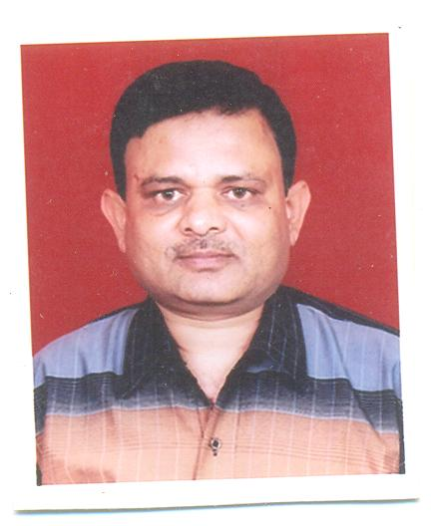
Pramod Kumar Yadav
E-mail: yadavpramod257@gmail.com Mobile No. +91- 9997283478
Working Experience: Above 30 Years

CARRER OBJECTIVE:-

- Wish to be part of professionally managed organization, where there is responsibility and opportunity to grow.
ACADEMIC QUALIFICATION:-

- Passed High School Examination from U.P. Board Allahabad in 1981 with IInd Division securing 59% Marks
- Passed Higher Secondary Examination (10+2) from U.P. Board Allahabad in 1983 with IInd Division securing 52.8% Marks
- Graduation from Kumaun University Nainital in 1985 with IInd Division securing 51.5% Marks
ADDITIONAL QUALIFICATION :

- Post Graduate Diploma in “EXPORT MANAGEMENT” in 1992 with 01st Division securing 73.5% Marks from The Management Studies Promotion Institute , New Delhi
COMPUTER LITERRACY:-

- Working Knowledge of Computer – MS-Office, Internet, & Tally ERP9.

WORKING EXPERIENCE: -

- As a “STORE INCHARGE” with M/s Kumaun Industries, Kashipur since 15/08/1986 to 28/02/1987.
- As an “EXCISE ASSISSTANT” with M/s Mukheja Rubbers Pvt. Ltd., Kashipur since 01/03/1987 to 31/12/1987.
- As a “COMMERCIAL INCHARGE” with M/S Carewell Mediproducst Limited (Manufacturer of Disposable Plastic Syringes & Needles-The Winner of Top Exporter Award from PLEXCONCIL in 1991 & 1995) since 15/01/1988 to 04/10/2003.
- As an “EXCISE INCHARGE” with M/s Jindal Agro Products Limited (Refinery Unit) since 15/10/2003 to 31/01/2005.
- As an “ACCOUNTS OFFICER” (01.02.2005 to 17.07.2011) & “ASSTT. MANAGER” (18.07.2011 to 13.10.2012) with M/s Safety Technology, Kashipur (A unit of Hi-Tech Group-Manufacturer of Disposable Plastic Syringes & Needles )

- As a “DEPUTY MANAGER- COMMERCIAL” With M/S India Meditek Limited, Haridwar ( Manufacturer of Disposable Plastic Syringes & Needles) since 15/10/2012 to 30th December-2012.

- As an “Accounts Officer” with M/s B.P. Packagings Pvt. Limited, Kashipur (Manufacturer of Corrugated Boxes) since 01st January-2013 to 15th March-2013.

- As an “Accounts Officer” with M/s Royal Pressing & Components, Mahuakheraganj, Kashipur (Manufacturer of Parts of Refrigerators & Washing Machine etc.) since 18th March-2013 to 25th August-2013.

- As “ Manager Commercial” with M/s Aman Medical Products Pvt. Ltd., Daman (A unit of Hi-Tech Group -Manufacturer of Disposable Plastic Syringes & Needles ) since 01st September-2013 to 28th November-2013

- As an “Accounts Officer” with M/s Samridhi Frozen Food Pvt. Ltd, Garhinegi, Tehsil Jaspur (Uttarakhand) since 01st December-2013 to 31st March-2014.

- Presently, I am employed as an “ Accounts Manager” with M/s Hydrochem Specialties Chemicals Pvt. Ltd, Kashipur since 01st April-2014 till date.

NATURE OF JOB RESPOSIBILITIES: -
- Daily Routine Work of GST, Yearly Sales Tax Assessment , Liaisoning with all Govt. Deptt. & all other commercial activities.

WORKING KNOWLEDGE:-

- Accounting work related to GST
- Making Sales Invoices
- E-mailing correspondence
- Vouchers entry i.e. Cash , Receipt , Contra, Sales , Purchase & Journal etc. in tally ERP-9
- Maintaining of all orders for Dispatch coordination transporters & suppliers
- Making Debit & Credit Notes in favour of vendors..
- To collect the quotation, prepare the rate comparison chart and put up for approval.
- Preparing of monthly Stock Report, Store stock, dispatch, and production..

Father’s Name : Shri N.M. Yadav
Date of Birth : 01st April-1966
Marital Status : Married
Present & Parmament : 402, Pushp Vihar, Avas Vikas
Address Kashipur-244713
Personal Information

Distt. Udham Singh Nagar Salary Drawn : : Rs. 32000=00 P.M.
Salary Expected: Negotiable

PLACE: KASHIPUR
DATE : 28.07.2021 ( PRAMOD KUMAR YADAV)

